TETRIS

About

It is a tile matching puzzle game. It consists of geometric shapes composed of four squares blocks each which keep on dropping from the top and lands at the bottom. Landing of a block triggers the downward movement of another block.  
  
The objective of the game is to manipulate these Tetrominoes, by moving each one sideways and rotating it by 90 degree units, with the aim of creating a horizontal line of ten blocks without gaps. When such a line is created, it disappears, and any block above the deleted line will fall. The game ends when the stack of Tetrominoes reaches the top of the playing field and no new Tetrominoes are able to enter.

Types of Blocks

* I-blocks are useful for getting 'Tetris', that is competing four lines at once.

[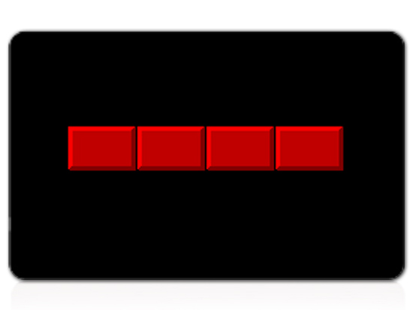](http://www.wikihow.com/Image:Play-Tetris-Step-4Bullet1.jpg)

* O-blocks for filling large gaps.

[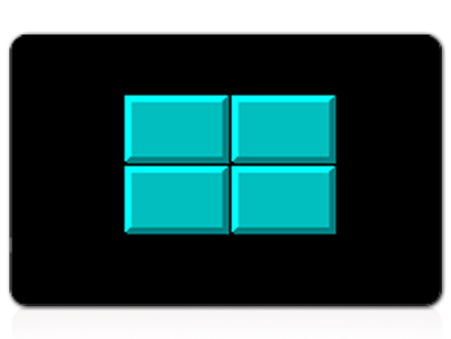](http://www.wikihow.com/Image:Play-Tetris-Step-4Bullet2.jpg)

* L-blocks for filling medium-sized holes.

[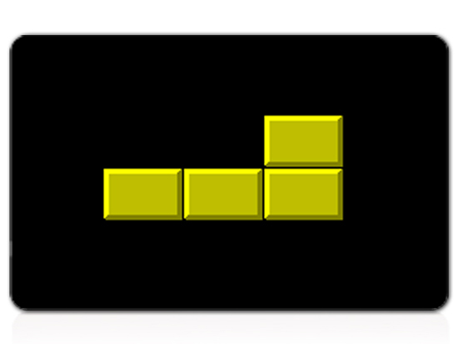](http://www.wikihow.com/Image:Play-Tetris-Step-4Bullet3.jpg)

* J-blocks face the opposite direction as L-blocks.

[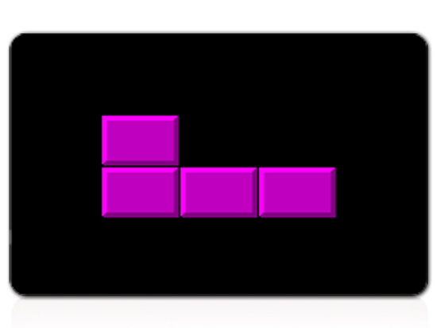](http://www.wikihow.com/Image:Play-Tetris-Step-4Bullet4.jpg)

* S-blocks for filling small holes.

[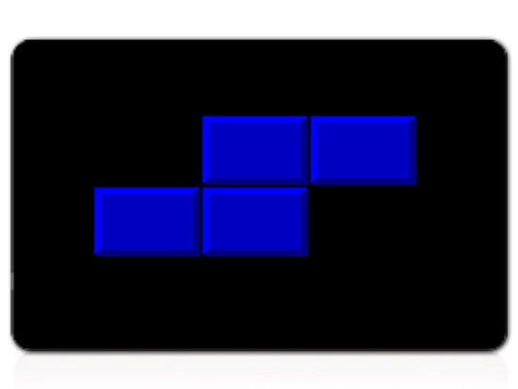](http://www.wikihow.com/Image:Play-Tetris-Step-4Bullet5.jpg)

* Z-blocks face the opposite direction as S-blocks.

[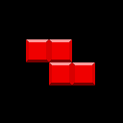](http://www.wikihow.com/Image:Tetromino-Z_972.png)

[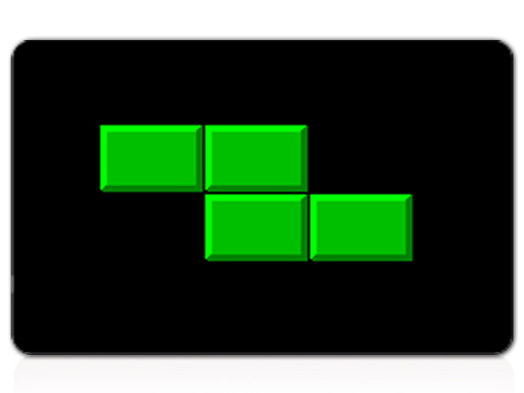](http://www.wikihow.com/Image:Play-Tetris-Step-4Bullet6.jpg)

* T-blocks are also for filling small holes.

[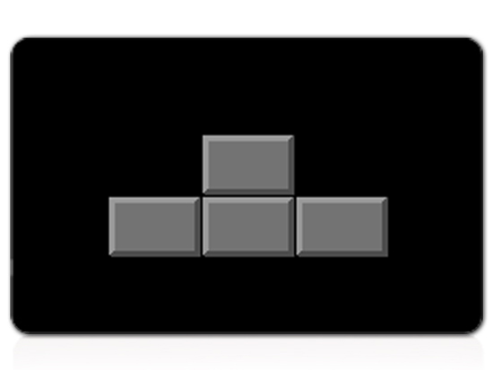](http://www.wikihow.com/Image:Play-Tetris-Step-4Bullet7.jpg)

How To Play

1. Start the game.
2. Use left and right arrow keys to move tetrominoes left and right respectively.
3. Use space bar to rotate tetrominoes to fit holes. Tetrominoes rotate by 90 each time we press space bar.
4. Complete lines to gain points. The more lines completed at once, the more points gained. Completing the maximum number of lines at once, four, is known as a Tetris.
5. We can use down arrow to move the tetrominoes faster.
6. The speed of dropping tetrominoes increases with increase in level.
7. Level increases in every two minute.

Objective & Scoring

The main objective of the game is eliminating blocks by completing a horizontal line of blocks. Whenever a line completes score add up as follows :-

|  |  |  |  |  |
| --- | --- | --- | --- | --- |
| Level | Points for  1 line | Points for  2 line | Points for  3 line | Points for  4 line |
| 1 | 40 | 100 | 300 | 1200 |
| 2 | 80 | 200 | 600 | 2400 |
| 3 | 120 | 300 | 900 | 3600 |
| 4 | 160 | 400 | 1200 | 4800 |

How game ends?

Game ends as we reach the top and there is no place for tetrominoes to enter.